*Florida International University*

*School of Computing and Information Sciences*

Software Engineering Focus

Feature Document

User Story #117

Create a homepage with high-tech look

**Name:** Mariana Sebastian

**Team Member(s):** Nathally Perez

**Project:** Driverless Car Website 1.0

**Product Owner(s)**:Kianoosh G. Boroojeni

**Mentor(s)**: Mohsen Taheri

**Instructor**: Masoud Sadjadi

**User Story Name:** Create a homepage with high-tech look

* As a user I would like to be presented with a high tech home page so that I could find the information very easily.

Acceptance Criteria

* Homepage should contains Headers and Footers
* Homepage should contains About us, technology, products, contact Us tabs

**Use Case #117**

* Name: Create Home page
* Actor: site visitor
* Preconditions: Connected to http://localhost:3000
* Description:

1. Users can find tabs about about us, technology, product, team, contact us in the header section.
2. User can scroll down to find more information in the website
3. User can find the footer with copyright information at the bottom of the website.

**Use Case Diagram**

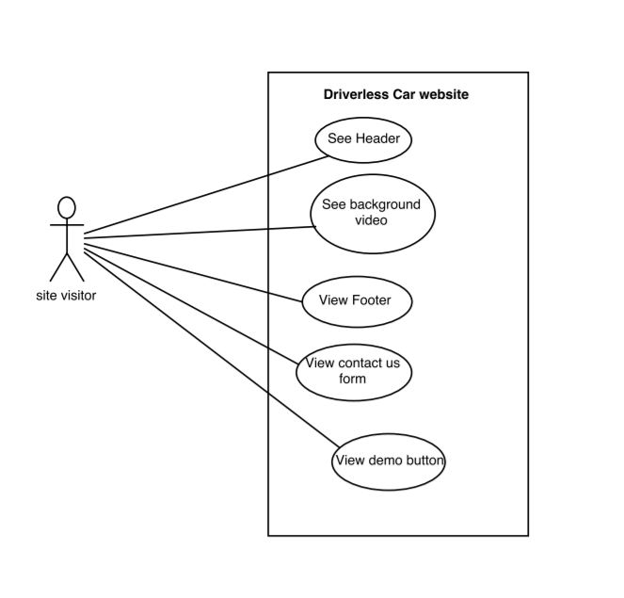

**Sequence Diagram**

Untitled Diagram.png

**Class Diagram**:**N/A**

**Unit Test**

**Test Case 1 (Sunny Day)**

* **Test case ID:** Homepage_001
* **Description/Summary of Test:** To test that header of the homepage is displaying with correct tabs.
* **Precondition:** Server is up and running.
* **Input:** User opens the browser and enters http://localhost:3000
* **Expected Results:** Web page is displayed with homepage showing header and the tabs.
* **Actual Result:** Web page is displayed with homepage showing header and the tabs.
* **Status (Fail/Pass)**:PASS

**Test Case 2 (Sunny Day)**

* **Test case ID:** Homepage_002
* **Description/Summary of Test:** To test that homepage can be viewed in different browser
* **Precondition:** Server is up and running.
* **Input:**

1. User opens google chrome browser and enters <http://localhost:3000>.
2. User opens Mozilla firefox browser and enters <http://localhost:3000>.
3. User opens Safari browser and enters http://localhost:3000.

* **Expected Results:** Web page is launched with homepage in each browser
* **Actual Result:** Web page is launched with homepage in each browser
* **Status (Fail/Pass)**:PASS

**Test Case 3(Rainy Day)**

* **Test case ID:** Homepage_002
* **Description/Summary of Test:** To test that the homepage won’t display if the user enter incorrect web address.
* **Precondition:** Server is up and running.
* **Input:** User opens the browser and enters [http://localhost](http://localhost:3000).
* **Expected Results:** Web page is not displayed with homepage.
* **Actual Result:** Web page is not displayed with homepage.
* **Status (Fail/Pass)**:PASS

**Visual User Guide**

